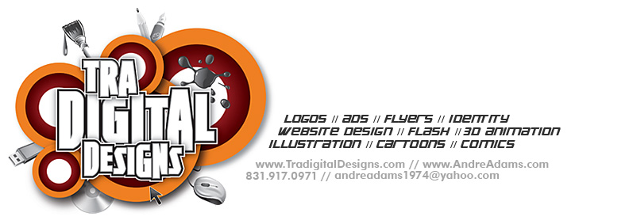
Objective
Seeking a challenging role as a mid-level Graphic Designer and/or Multimedia Developer, where I could continue to grow as an artist and help take projects to the next level.
Work Experience Independent
Independent contractor & Freelancer-- As Creative Director of Tradigital Designs, I provide creative print and web solutions for ad agencies, design shops, animation studios, magazines, newspapers and business owners. Founder of The Cartoon Express, a micro-stock site where users can browse & download vector illustrations, animations, logos, and design tutorials. Expertise in logos and branding, designing ads, brochures, business cards, direct mail, emailers, packaging, annual reports, graphics, icons, labeling, giftware, illustration, cartooning, character creation, 2D & 3D animation, avatars, mobile apps, and interactive & instructional design. (1995-present).
Work Experience Companies
• Employed as an independent contractor for e-learning company ischool Zambia, where I create animations, illustrations & interactive e-learning modules (July 2012-present).
• 2D/3D Animator and Flash Developer - L-3 Communications/GS&ES (Monterey, CA) I created talking avatars for 10 different languages, edited audio and video files, created Flash cartoons and developed instructional material in support of the DLI (Defense Language Institute) used by the Army. I also filled in as Creative Lead for the Animation Department (September 2006-September 2008).
• Graphic Designer - The Wave Magazine (San Jose, CA) I was responsible for designing full-color ads and flyers for Silicon Valley's most widely circulated Entertainment magazine, as well as color correcting photos and publishing the magazine's website. (October 2005-September 2006).
• Graphic Designer & Illustrator - Excelligence Learning Corporation (Monterey, CA) I provided illustrations, designed and produced catalogs, created ads, posters, cover comps, and worked with the product development/marketing teams to develop children's educational products. I was responsible for the layout, design and packaging of more than 100 products, of which many went on to become top selling items (September 2002-October 2005).
(continued)
Education
• B.A. in Commercial Art; emphasis in illustration and graphic design. Minored in Journalism.
American Intercontinental University, Los Angeles, CA. 1996
• Art study classes included Art History, Advertising and Marketing, Animation, Illustration, Painting, Graphic Design and Layout, Multimedia, Typography, and Desktop Publishing.
Skills
• Fluent in Adobe’s CS6 (Photoshop, Illustrator, InDesign, After Effects, Flash, Dreamweaver, etc.), Poser; Quark X-Press; familiar with CorelDraw!, HTML, XML, action-scripting, Microsoft Office.
• Experienced in all traditional media – color pencil, charcoal, pastel, watercolor, oil, marker, airbrush, etc.
• Comfortable working on both Mac and PC platforms.(OS Snow Leopard and Windows 7/8)
• Conversational French & Russian. I have lived in France, Belgium, and Russia. Travel and language buff.
Activities
* Member of Society of Illustrators, AIGA, and ASIFA-Hollywood (animation org).
* Actively involved in team sports (especially football), fan of Comic-Con, & volunteer for local/community events. Creator of web comic www.freedomfries.co.

Andre Adams // www.andreadams.com // 831.917.0971 // andre@andreadams.com

